**HW #4**

Anish Addla

Concordia University

Applied Restful APIs&Integrat

Dr. Michael Litman

January 20, 2025

DATA

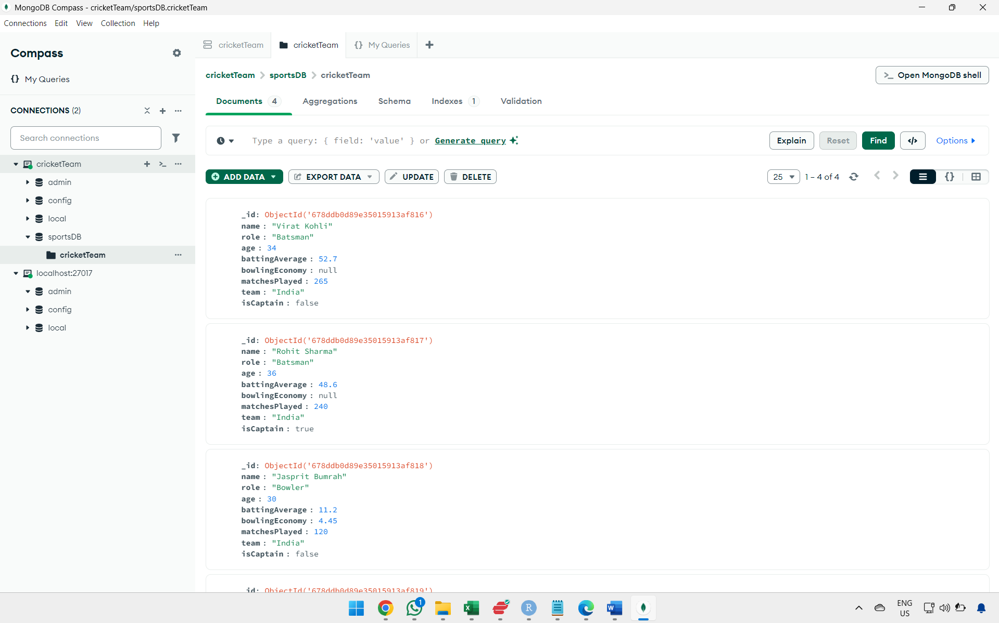

1.

2.

3.

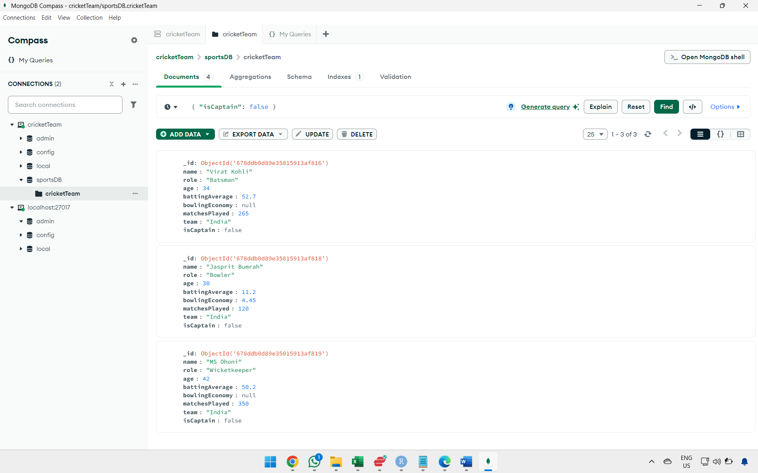

4.

5.

